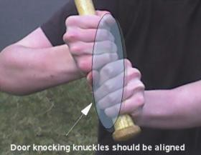
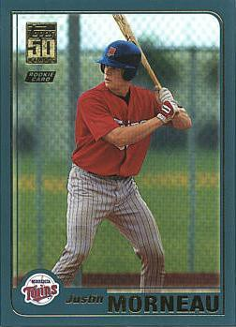
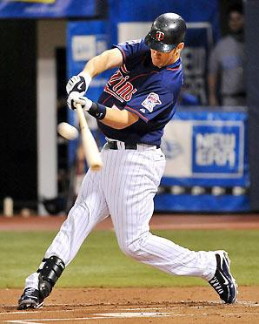
WYB Player Training Guide
LESSON: Spartan Hitting Progression

PURPOSE: Learn Hitting Fundamentals consistent with WYB hitting progression
Step 1: Plate Coverage
Straight arm + Bat to end of plate

Step 2: Grip
Knuckles aligned, Index Finger Test, Fingers not Palms

Step 3: Stance Square feet to pitcher
Head Square and Eyes Level
Chin over toes (knee flex, balls of feet) Hands at top of strike zone (up, back, in)
Feet as wide as the bat (first use outside shoulders)
Bat at 45 degrees (knob points to opposite batter’s box)

Step 4: Stride
TO HIT not AND HIT
Land ball of inside of foot
Foot down and hands get back over back foot (trigger)
Weight is still back on stride (should be able to pick stride foot up and re-stride)
Straight to pitcher to be in a square hitting position

Step 5: Pivot
"Show cleats to the catcher" "High heel" is our terminology

Step 6: Swing Barrel head to ball
Lead barrel head to ball with knob Palm up – Palm down

Step 7: Follow Through Support two hand finish Balance --not falling over
Checkpoints – head, eyes, back knee, back heel, belly button to pitcher

